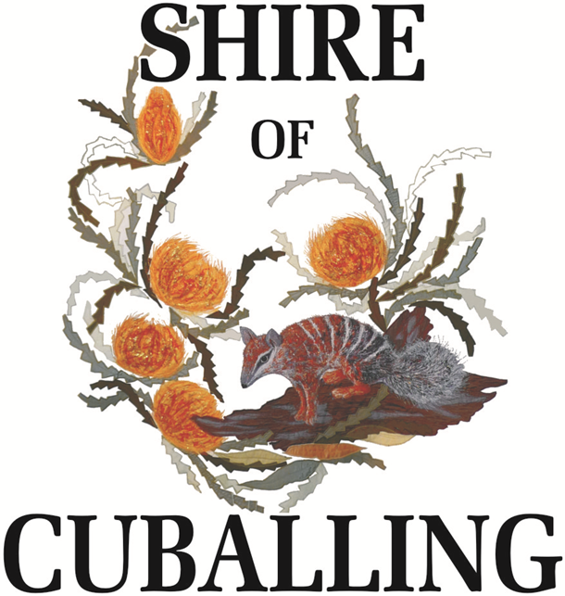

Position Description

GENERAL HAND/PLANT OPERATOR

SHIRE OF CUBALLING

GENERAL HAND/PLANT OPERATOR

Position Description

1. TITLE: General Hand/Plant Operator

2. LEVEL: Level 4 of Local Government Industry Award 2020 (Depending on Experience)

3. DEPARTMENT: Works Department

4. BASIC FUNCTIONS:

Under the direction of the Manager of Works & Services, or in his absence, the Leading Hand, complete road construction or road maintenance duties, cart materials i.e. gravel, blue metal, sand, culvert pipes etc., necessary to carry out road maintenance and construction throughout the Shire of Cuballing.

Assist with other work such as concreting footpaths, private works, tree lopping, rubbish removal, maintaining of parks, ovals and gardens and carting of non-road making materials as required.

5. REQUIREMENTS OF THE JOB:

To maintain the Shire roads to a high standard and undertaking other duties required by the Manager of Works & Services.

- KEY DUTIES/RESPONSIBILITIES

To operate loader, grader and other equipment (as required) provided by the Shire of Cuballing to carry out roadworks.

To operate the equipment in a responsible manner and to observe safety standards to ensure his/her colleagues or members of the public are not threatened by careless acts.

Ensure equipment provided by the Council is maintained and cleaned appropriately.

To co-operate with the other works crew members to ensure the works programme is completed efficiently and effectively.

Any other duties as required by the Manager of Works or Chief Executive Officer.

- CONDITIONS OF EMPLOYMENT

7.1 Award Classification

Level 4 of the Local Government Industry Award 2020, plus allowances and overtime where applicable.

7.2 Superannuation

a) Occupational superannuation (compulsory) - Council currently contributes 11.5% of salary.

b) Local Government superannuation (non-compulsory) - Council currently offers a matching contribution of up to a maximum of 6% of salary based on the individual contribution from an employee. All necessary requirements must be satisfied in accordance with the Local Government Superannuation Scheme.

7.3 Annual Leave

Four (4) weeks per annum with 17.5% Leave Loading after 12 months service.

7.4 Long Service Leave

After ten (10) years of service.

7.5 Sick Leave

As per Local Government Industry Award 2020.

7.6 Hours

The regular hours of work are 76 ordinary hours per fortnight as per the Local Government Industry Award 2020 with an additional amount of scheduled overtime totalling 4½ hours of overtime each fortnight.

These hours are worked as a nine day fortnight made up as follows:

Wednesday 7.00 am - 4.30 pm (½hr lunch) 9 hrs (Pay Day)
Thursday 7.00 am - 4.00 pm (½hr lunch) 8.5 hrs
Friday Rostered Day Off
Monday 7.00 am - 4.30 pm (½hr lunch) 9 hrs
Tuesday 7.00 am - 4.30 pm (½hr lunch) 9 hrs
Wednesday 7.00 am - 4.30 pm (½hr lunch) 9 hrs
Thursday 7.00 am - 4.30 pm (½hr lunch) 9 hrs
Friday 7.00 am - 4.30 pm (½hr lunch) 9 hrs
Monday 7.00 am - 4.30 pm (½hr lunch) 9 hrs
Tuesday 7.00 am - 4.30 pm (½hr lunch) 9 hrs

By agreement with staff, the normal start and finish times of work may be altered. This is most often done during summer with an earlier start and finish time.

When a Public Holiday falls on a Rostered day off the day following the Public Holiday will be taken as the Rostered day off.

7.7 Probationary Employment Period

In accordance with Council Policy, a probationary employment period of up to six (6) months shall apply. Employee performance will be subject to Executive assessment prior to confirmation of continued employment.

- ORGANISATION RELATIONSHIPS

8.1 Responsible to: Manager of Works & Services
(or in his absence the Works Supervisor)

8.2 Internal & External Liaison

Internal - Manager of Works & Services
Works Supervisor
Leading Hand
Colleagues

External - Local Residents
Local Organisations

- EXTENT OF AUTHORITY – Nil

- SELECTION CRITERIA

- Must meet minimum literacy requirements.

- Must be reliable and able to work within a small team.

- Must be the holder of a current MDL class HR.

- Must hold safety awareness card eg. White/Blue Card.

- Must be able to demonstrate an ability to operate and maintain Council’s plant and equipment.

- Have traffic management accreditation

- At least three years experience in road construction and road maintenance is desirable but not essential.

11. OCCUPATIONAL HEALTH & SAFETY

  - Risk Management

    - Comply with the Shire’s Risk Management Policy Procedures.

    - Actively participate in the Risk Management Program and Organisational Performance Review and Evaluation Program.

    - Actively participate in the Shire’s Continuous Improvement Program.

Employees Responsibilities

    - Conform with the duty of care requirements, ensuring their own safety and that of others, through the prevention of any adverse acts or omissions.

    - Must comply with the safety procedures and directions agreed between management and employees with nominated or elected safety and health representatives

    - Must not willfully interfere with or misuse items or facilities provided in the interests of safety and health of Council employees

    - Must use, store and maintain items, equipment and facilities provided in the interests of safety and health (protective clothing, machine guards, first aid provisions etc) in a manner in which he/she has been properly instructed.

    - Must, in accordance with Council procedures for accident and incident reporting, report potential and actual hazards and accidents/incidents to their supervisor and/or safety and health representatives

    - Must co-operate with the employer in the carrying out of their obligations (S 20 OS&H act)

Must comply with the Council Work Injury Management Program

Accepted

____________________________
Signed

____________________________ Dated ________________
Employee Name

____________________________ Dated ________________
Approved by Manager Works & Services

Reviewed __________________

