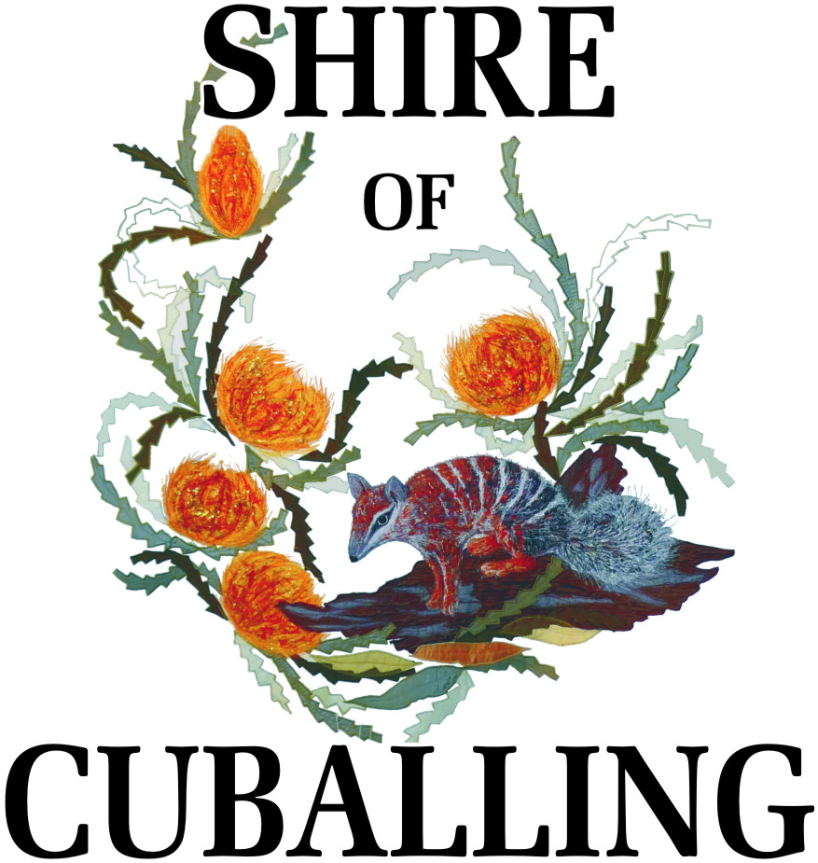

MINUTES

FOR

Electors’ General Meeting

Held on

Thursday, 19th March 2015

at the

Shire of Cuballing Council Chambers

These minutes were confirmed at the Ordinary Meeting held on Thursday 23rd April 2015.

Signed……………………………………………………………………………
Cr Mark Conley, Shire President

Thursday 23rd April 2015

DISCLAIMER

No responsibility whatsoever is implied or accepted by the Shire of Cuballing for any act, omission or statement or intimation occurring during Council/Committee meetings or during formal/informal conservations with staff.

The Shire of Cuballing disclaims any liability for any loss whatsoever and howsoever caused arising out of reliance by any person or legal entity on any such act, omission or statement or intimation occurring during Council/Committee meetings or discussions.

Any person or legal entity who acts or fails to act in reliance upon any statement does so at that person’s or legal entity’s own risk.

In particular and with derogating in any way from the broad disclaimer above, in any discussion regarding any planning application or application for a licence, any statement or limitation of approval made by a member or officer of the Shire of Cuballing during the course of any meeting is not intended to be and is not taken as notice or approval from the Shire of Cuballing.

The Shire of Cuballing warns that anyone who has an application lodged with the Shire of Cuballing must obtain and only should rely on WRITTEN CONFRIMATION of the outcome of that application and any conditions attaching to the decision made by the Shire of Cuballing in respect of the application.
1. OPENING - ANNOUNCEMENT OF VISITORS

The Shire President, Cr Conley, declared the meeting open at 6.33pm.

2. ATTENDANCE, APOLOGIES, LEAVE OF ABSENCE

Cr Mark Conley President
Cr Roger Newman Deputy President
Cr Scott Ballantyne
Cr Eliza Dowling
Cr Tim Haslam
Cr Dawson Bradford

Mr Gary Sherry Chief Executive Officer
Ms Tonya Williams Deputy Chief Executive Officer
Mr Bruce Brennan Works Supervisor

Mr Colin Hawksley
Mrs Jenny Hawksley
Mr Henry Rozmianic
Mr Sheldon Paice
Mrs Carol McDougall

3. MINUTES

3.1 Confirmation Of The Minutes Of Electors’ General Meeting Held On Thursday 17th April 2014 In The Council Chamber

DECISION:

That the Minutes of the Shire of Cuballing Electors’ General Meeting held on Thursday 17th April 2014 in the Council Chamber be confirmed as a true and correct record

Moved: Cr Dowling Seconded: Cr Ballantyne
Carried

4 ANNUAL REPORT

The Shire President, Cr Conley, read his President’s Report for the 2013/14 year.

Decision

Moved: Cr Haslam Seconded: Cr Newman

That the Annual Report of the Shire of Cuballing for the year ended 30th June 2014 be received
Carried

5. GENERAL BUSINESS

5.1 Regional Waste Disposal Site

Mr Colin Hawksley asked what remuneration is being offered for the admin costs of the Proposed Regional Waste Site?

The Shire President, Cr Conley, advised that Council meets the cost of administration associated with planning applications. The Regional Waste site is a large application. Council does also charge fees associated with planning approvals.

5.2 Regional Waste Disposal Site

Mr Colin Hawksley asked what are the Shires for plans for the Transfer Stations?

The Chief Executive Officer, Mr Sherry, advised that Council had allocated $60,000 in Council’s 2014/15 budget to construct two transfer stations. Council will also receive grant funding of $20,000.

5.3 Regional Waste Disposal Site

Mr Hawksley asked if local brigades were equipped to handle fires in a Regional Waste Disposal Site?

The Works Supervisor, Mr Brennan, advised that Council’s Volunteer Bush Fire Brigades are not trained or equipped to handle structural fires or fires with toxic gases.

5.4 Number of Councillors

Mr Hawksley asked if Council was going to continue with only six Councillors?

The Shire President, Cr Conley, advised that Council would continue with six Councillors. During recent local government reform it was thought by the Local Government Minister that Council’s needed between 6 and 9 Councillors and the Shire of Cuballing was at the lower end of this number.

5.5 Regional Waste Disposal Site

Ms Jenny Hawksley asked about the fencing of the Regional Waste Disposal Site. If a 2 metre high fence wasn’t on the boundary, how would waste be contained on the site?

The Chief Executive Officer, Mr Sherry, advised that it was a Department of Environment Regulation requirement that the operation be contained with a 2 metre high fence, however this fence was not required to be on the property boundary. A normal rural fence could be erected on the boundary of the property, with the higher fence erected closer to the operation.

5.6 Regional Waste Disposal Site

Mr Sheldon Paice asked about the upgrading of Nebrikinning Road in the event the Regional Waste site is constructed? Will there be a contribution from Great Southern Regional Waste Group?

The Chief Executive Officer, Mr Sherry, advised that it was possible that contribution from the Great Southern Regional Waste Group would be requested by Council should the Regional Waste Site proceed. The amount of the contribution would reflect the amount of traffic use that would come from the Regional Waste Disposal Site Operation. The Shire of Cuballing is are currently collecting data to establish baseline levels of traffic on Nebrikinning,

5.7 Regional Waste Disposal Site

Mr Sheldon Paice asked about the cost of feral animal control at the Regional Waste Site and would a contribution from the Great Southern Regional Waste Group be made.

The Chief Executive Officer, Mr Sherry, advised that this cost of implementing a feral animal management plan would be the responsibility of the Great Southern Regional Waste Group.

5.8 Control of Rabbits

Mr Henry Rozmianic noted the increased numbers of rabbits in Cuballing and asked if Council could complete some control activities.

The Chief Executive Officer, Mr Sherry, agreed with the seriousness of this issue and advised that Council was currently baiting rabbits at some locations in Cuballing.

5.9 Barking Dogs

Mr Henry Rozmianic spoke about the issue of noisy dogs and the requirement for owners to be responsible. Mr Rozmianic asked that Council continue to advertise encouraging people to control their dogs barking.

5.10 Cuballing Cemetery and Public Toilets

Ms Carol McDougall advised that she had 4 things she wished to raise:

- at the Cuballing Cemetery there a four pine logs and steel supports standing up. Is the Shire going to fix this?

The Works Supervisor, Mr Brennan, advised that he was aware of the posts and was scheduling them to be taken down.

- A sign at the Cuballing Cemetery would improve the amenity of the Cemetery.

- The Toilets at the skate park in Cuballing are a disgrace, particularly in comparison to the Popanyinning toilets that improve streetscape. Can anything be done?

The Chief Executive Officer, Mr Sherry, advised that while the Skate Park Toilets are drop toilets, they are cleaned to a very high standard. Any improvement would be a significant investment by Council and at this time there are no plans to replace the toilets.

- What is being done to complete the entry statement at the north end of town?

The Shire President, Cr Conley, advised that completion of the entry statements at both the north and south end of Cuballing were a priority.

MEETING CLOSURE

There being no further business, the Shire President, Cr Conley, closed the meeting at 7.08 pm

