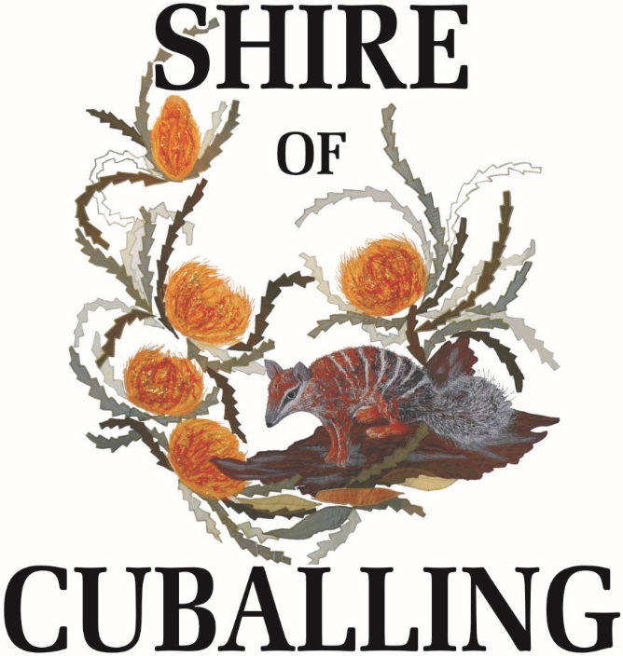

A progressive, diverse and caring community,
with access to modern services and infrastructure,
in a unique part of the world

Minutes

of the

Special Meeting of Council

held

10AM, Tuesday 30th June 2015

Shire of Cuballing
Council Chambers
Campbell Street, Cuballing

DISCLAIMER

No responsibility whatsoever is implied or accepted by the Shire of Cuballing for any act, omission or statement or intimation occurring during Council/Committee meetings or during formal/informal conservations with staff. The Shire of Cuballing disclaims any liability for any loss whatsoever and howsoever caused arising out of reliance by any person or legal entity on any such act, omission or statement or intimation occurring during Council/Committee meetings or discussions. Any person or legal entity who acts or fails to act in reliance upon any statement does so at that person’s or legal entity’s own risk.

In particular and with derogating in any way from the broad disclaimer above, in any discussion regarding any planning application or application for a licence, any statement or limitation of approval made by a member or officer of the Shire of Cuballing during the course of any meeting is not intended to be and is not taken as notice or approval from the Shire of Cuballing. The Shire of Cuballing warns that anyone who has an application lodged with the Shire of Cuballing must obtain and only should rely on WRITTEN CONFIRMATION of the outcome of that application and any conditions attaching to the decision made by the Shire of Cuballing in respect of the application.

Agenda

1. DECLARATION OF OPENING: 4
2. ATTENDANCE/APOLOGIES/LEAVE OF ABSENCE: 4
2.1.1 Attendance 4
2.1.2 Apologies 4
2.1.3 Leave of Absence 4
3. STANDING ORDERS: 4
4. PUBLIC QUESTION TIME: 4
4.1 RESPONSE TO PREVIOUS QUESTIONS TAKEN ON NOTICE: 4
4.2 WRITTEN QUESTIONS PROVIDED IN ADVANCE: 4
4.3 PUBLIC QUESTIONS FROM THE GALLERY: 5
5. APPLICATIONS FOR LEAVE OF ABSENCE: 5
6. CONFIRMATION OF MINUTES: 5
7. PETITIONS/DEPUTATIONS/PRESENTATIONS/ SUBMISSIONS: 5
8. DISCLOSURE OF FINANCIAL INTEREST: 5
9. REPORTS OF OFFICERS AND COMMITTEES: 6
9.1 DEPUTY CHIEF EXECUTIVE OFFICER: 6
9.1.1 Draft 2015/2016 Budget 6
9.2 CHIEF EXECUTIVE OFFICER: 9
9.3 WORKS SUPERVISOR’S REPORT: 9
9.4 ENVIRONMENTAL HEALTH OFFICER: 9
9.5 BUILDING OFFICER: 9
10. ELECTED MEMBERS’ MOTION OF WHICH PREVIOUS MOTION HAS BEEN GIVEN: 9
11. URGENT BUSINESS WITHOUT NOTICE WITH THE APPROVAL OF THE PRESIDENT OR MEETING: 9
12. CONFIDENTIAL ITEM: 9
13. NEXT MEETING 9
14. CLOSURE OF MEETING: 9

DECLARATION OF OPENING:

The Shire President, Cr Conley, declared the Special Meeting open at 10.06 am.

ATTENDANCE/APOLOGIES/LEAVE OF ABSENCE:

2.1.1 Attendance

Cr Mark Conley President
Cr Roger Newman Deputy President
Cr Tim Haslam
Cr Scott Ballantyne
Cr Eliza Dowling
Cr Dawson Bradford

Mr Gary Sherry Chief Executive Officer
Ms Tonya Williams Deputy Chief Executive Officer
Mr Bruce Brennan Works Supervisor

2.1.2 Apologies

Nil

2.1.3 Leave of Absence

Nil

STANDING ORDERS:

COUNCIL DECISION:

That Standing Orders be suspended for the duration of the meeting to allow for greater debate on items.

Moved: Cr Newman Seconded: Cr Dowling
Carried 6/0

PUBLIC QUESTION TIME:

RESPONSE TO PREVIOUS QUESTIONS TAKEN ON NOTICE:

Nil. Questions from the last Ordinary Meeting of Council taken on notice will be included in the Agenda for the next Ordinary Meeting to be held at 3pm, Thursday 17th July 2015.

WRITTEN QUESTIONS PROVIDED IN ADVANCE:

Nil

PUBLIC QUESTIONS FROM THE GALLERY:

Nil

APPLICATIONS FOR LEAVE OF ABSENCE:

Nil

Cr Ballantyne entered the chamber at 10:07 am.

CONFIRMATION OF MINUTES:

Nil. The confirmation of minutes from the last Ordinary Meeting of Council will be included in the Agenda for the next Ordinary Meeting to be held at 3pm, Thursday 17th July 2015.

PETITIONS/DEPUTATIONS/PRESENTATIONS/
SUBMISSIONS:

Nil

DISCLOSURE OF FINANCIAL INTEREST:

DISCLOSURE OF FINANCIAL INTEREST AND PROXIMITY INTEREST

Members must disclose the nature of their interest in matters to be discussed at the meeting.

Employees must disclose the nature of their interest in reports or advice when giving the report or advice to the meeting.

DISCLOSURE OF INTEREST AFFECTING IMPARTIALITY

Members and staff must disclose their interest in matters to be discussed at the meeting in respect of which the Member or employee has given or will give advice.

Nil

REPORTS OF OFFICERS AND COMMITTEES:

9.1 DEPUTY CHIEF EXECUTIVE OFFICER:

9.1.1 Draft 2015/2016 Budget

Applicant: | N/A
File Ref. No: | F9
Disclosure of Interest: | Nil
Date: | 25th June 2015
Author: | Ms Tonya Williams
Attachments: | Draft 2015/2016 Budget included separately

Summary

Council is to consider items to be included in the draft 2015/2016 Budget.

Background

Council is to discuss Council’s 2015/2016 Draft Budget with a view to finalising the priority of those matters to be included in the document.

The finalised Council’s 2015/2016 Budget is expected to be adopted at the Ordinary Council Meeting to be held at the Shire of Cuballing on Thursday 16th July 2015.

Comment

In reviewing the 2015/16 Draft Budget, Council should note that:

1. A 5% rate increase has already been presumed and included in calculations;

2. The Draft Budget is presented as a deficit budget with nearly every activity discussed by Council at some time include in the Draft Budget. Therefore currently a total of $59,551 is required to be cut from expenditure programs and/or increased in revenue collections to balance the Draft Budget;

3. Staff have prioritised the discretionary expenditure in the Officer’s Recommendation, with the first activities listed being those activities assessed as a lower priority. It is anticipated that upon review Council will reach a consensus decision of funding priorities for the coming year;

Details | Cost | Rates Requirement in Draft Budget | 2015/16 Rates 5 % Increase | Draft Budget Deficit/ (Surplus)
 |  | - 1,130,745 | 1,070,794 | -59,551
Integrated Planning | $23,040 | - 1,107,705 | 1,070,794 | -36,911
Local Laws Review | $15,000 | - 1,092,705 | 1,070,794 | -21,911
Popanyinning School Repairs | $25,000 | - 1,067,705 | 1,070,794 | 3,089
Dryandra County Visitors Centre Contribution | $2,500 | - 1,065,205 | 1,070,794 | 5,589
Equestrian Centre – Stabilise wall of arena | $5,000 | - 1,060,205 | 1,070,794 | 10,589
Depot Internet Upgrade | $2,000 | - 1,058,205 | 1,070,794 | 12,589
Details | Cost | Rates Requirement in Draft Budget | 2015/16 Rates 5 % Increase | Draft Budget Deficit/ (Surplus)
Community Group Contribution – Narrogin Arts | $2,000 | - 1,056,205 | 1,070,794 | 14,589
Back Office Fit out | $5,950 | - 1,050,255 | 1,070,794 | 20,539
Facebook | $1,000 | - 1,049,255 | 1,070,794 | 21,539
Waste Management:  Building at Popanyinning  Site Fence at Cuballing,  Man both tip/ transfer sites | $44,058 | - 1,005,197 | 1,070,794 | 65,597
Transfer Station Development $100,000 | $30,000 | - 975,197 | 1,070,794 | 95,597
Record Keeping Implementation | $16,000 | - 959,197 | 1,070,794 | 111,597
Local Planning Strategy Review | $15,000 | - 944,197 | 1,070,794 | 126,597
Community Events | $8,250 | - 935,947 | 1,070,794 | 134,847
Popanyinning Hall – painting | $4,000 | - 931,947 | 1,070,794 | 138,847
Traffic Lights | $30,564 | - 901,383 | 1,070,794 | 169,411
Depot Upgrade | $20,000 | - 881,383 | 1,070,794 | 189,411
Business Continuity:  Cloud Back Up  Disaster Recovery Audit,  Test of System | $13,000 | - 868,383 | 1,070,794 | 202,411
Entry Statement:  Cuballing Horse Signage  Popanyinning Entry Signage | $42,000 | - 826,383 | 1,070,794 | 244,411
Pocket Roman | $2,000 | - 824,383 | 1,070,794 | 246,411
Admin Building – power board for generator | $3,000 | - 821,383 | 1,070,794 | 249,411
Narrogin Regional Library Contribution ($1,000 Increase) | $6,000 | - 815,383 | 1,070,794 | 255,411
Aged Housing ($30,000 Reserve) | $33,000 | - 782,383 | 1,070,794 | 288,411

Strategic Implications - Nil
Statutory Environment – Nil
Policy Implications - Nil

Financial Implications

The budget will set Council’s approved expenditure for the 2015/2016 financial year.

Economic Implication - Nil

Environmental Considerations - Nil

Social Implications

Many projects contained within the 2015/2016 Annual Budget are focused on improving facilities within the general community.

Consultation - Nil

Options

Council may resolve:

- the Officer’s Recommendation;
- an amended Officer’s Recommendation; or
- to not set any priority at this time and set a meeting date to further discuss this matter.

Voting Requirements – Simple Majority

COUNCIL DECISION:

That Council adopt a priority ranking from lowest to highest priority of discretionary activities for possible inclusion of these discretionary activities in Council’s 2015/16 Budget as follows:

Details Budget Cost
Integrated Planning $23,040
Community Group Contribution – Narrogin Arts $2,000
Building Surveyors Vehicle $22,000
Local Laws Review $15,000
Roadside Tree Pruning $9,000
Narrogin Regional Library Contribution
($1,000 Increase) $1,000
Equestrian Centre – Stabilise wall of arena $5,000
Popanyinning School Repairs $25,000
Dryandra County Visitors Centre Contribution $2,500
Facebook $1,000
Local Planning Strategy Review $15,000
Popanyinning Hall – painting $4,000
Shire Depot Upgrade $20,000
Depot Internet Upgrade $2,000
Back Office Fit out $5,950
Waste Management: Building at Popanyinning;
Site Fence at Cuballing; Man both tip/
transfer sites $44,058
Transfer Station Development $100,000
($30,000 grant, $40,000 reserves) $30,000
Record Keeping Implementation $16,000
Community Events $8,250
Traffic Lights $27,785
Business Continuity: Cloud Back Up; Disaster
Recovery Audit, Test system $13,000
Entry Statement: Cuballing Horse/ Popanyinning
Entry Signage $42,000
Pocket Roman $2,000
Admin Building – power board for generator $3,000
Aged Housing $30,000 Reserve $33,000
Equestrian Arena $9,907

Moved: Cr Ballantyne Seconded: Cr Haslam
Carried 6/0

9.2 CHIEF EXECUTIVE OFFICER:

Nil

9.3 WORKS SUPERVISOR’S REPORT:

Nil

9.4 ENVIRONMENTAL HEALTH OFFICER:

Nil

9.5 BUILDING OFFICER:

Nil

ELECTED MEMBERS’ MOTION OF WHICH PREVIOUS
MOTION HAS BEEN GIVEN:

Nil

URGENT BUSINESS WITHOUT NOTICE WITH THE APPROVAL OF THE PRESIDENT OR MEETING:

Nil at this time

CONFIDENTIAL ITEM:

Nil

NEXT MEETING

The next Ordinary Meeting of the Shire of Cuballing will be 3pm, Thursday 16th July 2015 at the Shire of Cuballing Council Chambers, Campbell Street, Cuballing.

CLOSURE OF MEETING:

There being no further business, the Shire President, Cr Conley, closed the meeting at 2.30 pm.

