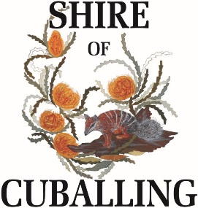
REGISTER OF CONTRIBUTIONS TO TRAVEL

Name of relevant person making disclosure | Description of contribution | Name of person who made contribution | Address of person who made contribution | Date contribution was received | Estimated value of contribution at time it was made | Nature of relationship between relevant person and person who made contribution | Description of travel | Date of travel
Elizabeth Dowling | Travel to PHCC Meetings | Peel Harvey Catchment Council | 58 Sutton Street, Mandurah 6210 | 5 October 2016 | $430.98 | Proxy member of the PHCC | Travel to Dwellingup, Boddington and Dryandra | 18 August 2016,  28 August 2016, and  29 August 2016
Mark Conley | Travel to Central Country Zone Meetings | Central Country Zone of WALGA |  | 26 May 2017 | $754.00 | Office Bearer of Central Country Zone of WALGA | Travel to meetings at Northam, Northam & Williams | 31st May 2016, 29th November 2016 and 7th February 2017
Elizabeth Dowling | Travel to PHCC Meetings | Peel Harvey Catchment Council | 58 Sutton Street, Mandurah | 1st June 2017 | $250.00 | Proxy member of the PHCC | Travel to Mandurah for a Peel Harvey Catchment Council meeting | 5th May 2017

